**ACTIVITY REPORT- (2023-2024)**

**EDUCATION AWARENESS PROGRAMME**

**KNOWLEDGE IS POWER, HARD WORK IS WORSHIP**

**AIMS:**

**Creating and establishing educational environment among poor and educationally backward people in the neighboring locality of the premises.**

Bringing awareness about importance of education in human society

Restricting children to play in streets, watching excessive TV/ playing with mobiles and wasting time without knowing their aims. Creating moral values among youths will be one of the main aims.

Encouraging people to participate in social activities that benefit masses.

Encouraging the youngsters to join government services particularly Judiciary, army and police so that grievances of backward classes particularly Muslims in future may be addressed with justice.

**Target:**

Young children (Class Ist to VIII standard) of at least fifty educationally backward and financially poor families are targeted every year to achieve excel in education and create educational and friendly atmosphere in the society.

By creating competitive atmosphere among students of higher classes (Class IX to XII), and to define their main goal and do efforts to achieve them. Extending all support to promising students. Providing Guidance to at least twenty, XII passed and graduate students to join government services particularly Judiciary, army and police.

**Methodology and Practice:**

By providing free reading room cum library with all facilities like proper sitting arrangement, power backup and a small collection of important books to all class students. This facility is available for twenty four hours to higher class students.

The facility is extended to lower class students with 2-3 teachers who are available for four hours daily from 4 pm to 8 pm to assist the young boys and girls in completing their day to day home work. Experienced and well qualified teachers of English, Sciences and Mathematics for students of class IX to XII are hired to help students in the preparation of board exams and competitive exams for UG programmes. Free wifi with a big screen facility is also made available to students all 24 hours.

Time to time the parents are requested to attend the motivating lectures to know how better environment at home may be created to uplift the children in the right direction.

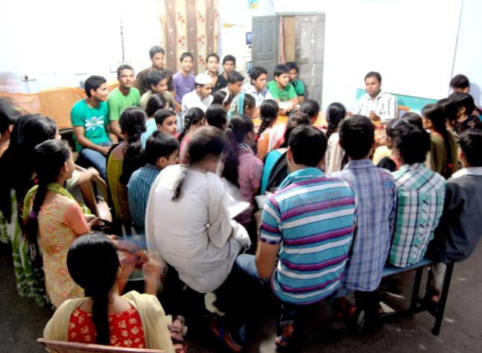

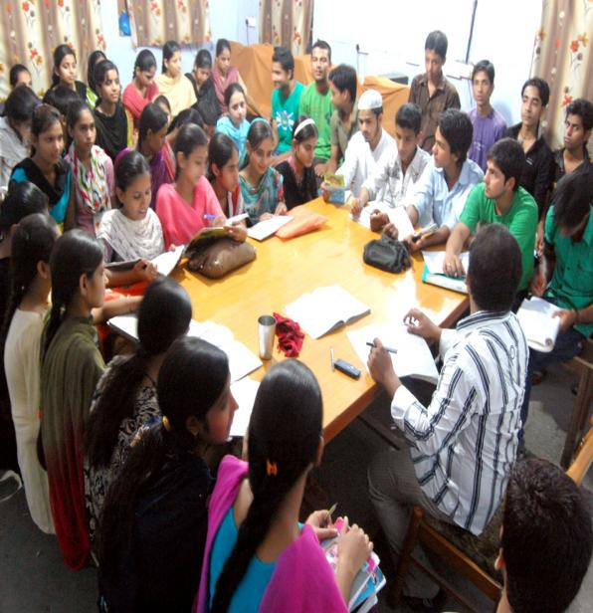

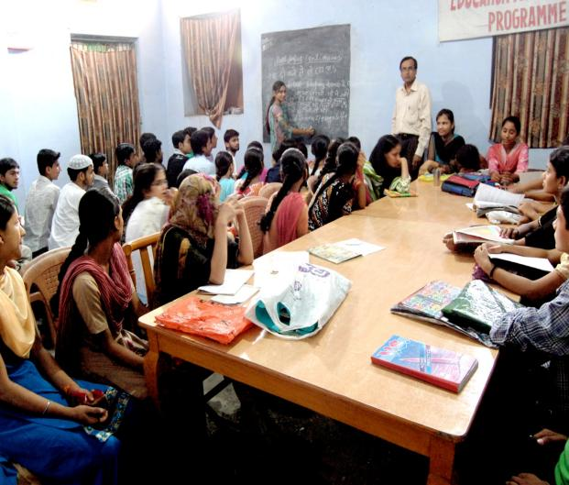

Dr Majid Jamil

Secretary